**Department of Electrical Engineering and   
Computer Science**

**Faculty Member:** Dr. Ahmad Salman **Dated:** 18/10/2023

**Semester:** 7th **Section:** BEE 12C

**CS-471 Machine Learning**

Lab 6: Linear Regression I

*Feature Scaling, Cost Function and Gradient Descent*

**Group Members**

|  |  |  |  |  |  |  |
| --- | --- | --- | --- | --- | --- | --- |
|  |  | **PLO4 - CLO4** | | **PLO5 -CLO5** | **PLO8 -CLO6** | **PLO9 -CLO7** |
| **Name** | **Reg. No** | **Viva / Quiz / Lab Performance** | **Analysis of Data in Lab Report** | **Modern Tool Usage** | **Ethics and Safety** | **Individual and Teamwork** |
|  |  | **5 Marks** | **5 Marks** | **5 Marks** | **5 Marks** | **5 Marks** |
| Afif Arif Siddiqi | 344504 |  |  |  |  |  |
| Muhammad Ali Farooq | 331879 |  |  |  |  |  |
| Muhammad Ahmed Mohsin | 333060 |  |  |  |  |  |
| Danial Ahmad | 331388 |  |  |  |  |  |
| Ehtishaam Tanveer | 333074 |  |  |  |  |  |
| Muhammad Umer | 345834 |  |  |  |  |  |

**Table of Contents**

2 Linear Regression I 3

2.1 Introduction 3

2.2 Objectives 3

2.3 Theory 3

3 Lab Tasks 4

3.1 Task 1 – Dataset Preparation 4

3.2 Task 2 – Feature Scaling 4

3.3 Task 3 – Cost Function 5

3.4 Task 4 – Gradient Descent Algorithm 6

3.5 Task 5 – Training Across Epochs 7

3.6 Task 6 – Hyperparameter Tuning 9

4 Conclusion 10

# Linear Regression I

## Introduction

This laboratory exercise will focus on the implementation of linear regression in python. Linear regression is a basic supervised learning technique which serves as a good starting point for learning supervised learning and sets the fundamental basis for learning other machine learning techniques. In linear regression, a dataset with various features and a label is trained. It consists of weighted parameters that are trained to fit a model that best approximates the dataset.

## Objectives

The following are the main objectives of this lab:

* Extract and prepare the training dataset
* Use feature scaling to ensure uniformity among the feature columns
* Implement cost function to get the overall loss
* Implement gradient descent algorithm to train the weight parameters
* Plot the training loss
* Use a prediction function to use the trained model

## Theory

Linear Regression is a very basic supervised learning technique. To calculate the loss in each training example, the difference between a hypothesis and the label (y) is calculated. The hypothesis is a linear equation of the features (x) in the dataset with the coefficients acting as the weight parameters. These weight parameters are initialized to random values at the start but are then trained over time to learn the model.

The cost function is used to calculate the error between the predicted y^ and the actual y. This cost is used to determine how the weights are to be adjusted in what is called the gradient descent algorithm. The gradient descent uses a step size (alpha) as a hyperparameter which can be tuned. This hyperparameter is varied to determine the model that best fits the dataset.

# Lab Tasks

## Task 1 – Dataset Preparation

You have been provided with a dataset containing several feature columns. You will need to select any 3 of the feature columns to make your own dataset. The “Sale Price” is the label column. Load the dataset into your python program as NumPy arrays (Xtrain, ytrain). Print the datasets (you need to show any 5 rows of the datasets).

### TASK 1 CODE STARTS HERE ###

*# Load the dataset into your python program as NumPy arrays (Xtrain, ytrain).*

dataset = pd.read_csv(path_data)

X_train = dataset[["BsmtFinSF1", "BsmtUnfSF", "TotalBsmtSF"]].values

y_train = dataset["SalePrice"].values

*# Print the arrays*

print("X_train:")

print(X_train[:5].T)

print("\ny_train:")

print(y_train[:5])

### TASK 1 CODE ENDS HERE ###

### TASK 1 OUTPUT SCREENSHOT STARTS HERE ###

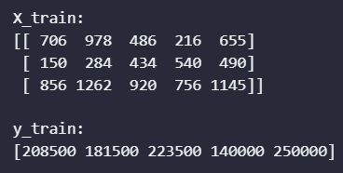

### TASK 1 OUTPUT SCREENSHOT ENDS HERE ###

## Task 2 – Feature Scaling

In the input matrix (Xtrain), use feature scaling to rescale the feature columns so that their values range from 0 to 1:

$$x_{j}{}_{scaled}^{\left(i\right)}=\frac{x_{j}{}_{max} – x_{j}{}^{(i)}}{x_{j}{}_{max} – x_{j}{}_{min}}$$

You will use these rescaled values in the upcoming tasks. Print the rescaled dataset (you need to show any 5 rows of the datasets).

### TASK 2 CODE STARTS HERE ###

*def* feature_scaling(*X*, *axis*=0):

    return (X - X.min(*axis*=axis)) / (X.max(*axis*=axis) - X.min(*axis*=axis))

X_train_scaled = feature_scaling(X_train)

print("Scaled X_train:")

print(X_train_scaled[:5].T)

print("\nMin: ", X_train_scaled.min(*axis*=0))

print("Max: ", X_train_scaled.max(*axis*=0))

### TASK 2 CODE ENDS HERE ###

### TASK 2 OUTPUT SCREENSHOTS START HERE ###

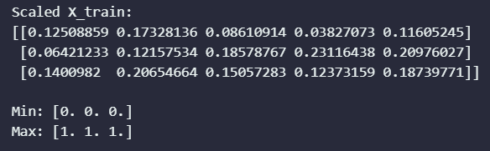

### TASK 2 OUTPUT SCREENSHOTS END HERE ###

## Task 3 – Cost Function

For linear regression, you will implement the following hypothesis:

h(x) = b + w1x1 + w2x2 + w3x3

The wj and b represent the weights while the xj represents the features. The feature number is denoted by j. The linear hypothesis h(x) is to be calculated for each training example and its difference with the label y of that training example will represent the loss. Initialize the weights and bias to random values between 0 and 1.

In this task, you will write a cost function that calculates the overall loss across a set of training examples:

cost_function(X, y)

The X and y are the features and labels of the training dataset. The function will return the cost value. The cost function is given by:

$$J(w)=\frac{1}{2m}\sum_{i=1}^{m}{(h(x^{(i)}) – y^{(i)})^{2}}$$

The m is the number of training examples in the dataset. Write the code for the cost function and implement it to print out the cost. Provide the code and all relevant screenshots of the final output.

### TASK 3 CODE STARTS HERE ###

*def* hypothesis(*X*, *w*, *b*):

    return b + np.dot(X, w)

*def* cost_function(*X*, *y*, *w*, *b*):

    assert len(X) == len(y), "X and y must have the same length"

    m = len(X)

    J = 1 / (2 * m) * np.sum((hypothesis(X, w, b) - y) ** 2)

    return J

*# Initialize the weights and bias to random values between 0 and 1.*

w = np.random.rand(3)

b = np.random.rand(1)

*# Verify the cost function*

print("Random weights [w]: ", w)

print("Random bias [b]: ", b)

print("\nCost: ", cost_function(X_train_scaled, y_train, w, b))

### TASK 3 CODE ENDS HERE ###

### TASK 3 OUTPUT SCREENSHOT STARTS HERE ###

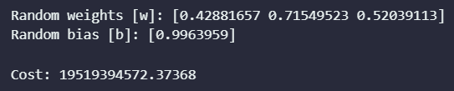

### TASK 3 OUTPUT SCREENSHOT ENDS HERE ###

## Task 4 – Gradient Descent Algorithm

In this task, you will write a function that uses gradient descent to update the weight parameters:

gradient_descent(X, y, alpha)

The X and y are the features and labels of the training dataset, *alpha* is the learning rate which is a tuning hyperparameter. The gradient descent algorithm is given as follows:

$$dw_{j}=\frac{∂J}{∂w_{j}}=\frac{1}{m}\sum_{i=1}^{m}{(h(x^{\left(i\right)}) – y^{\left(i\right)}){x_{j}}^{(i)}} db=\frac{∂J}{∂b}=\frac{1}{m}\sum_{i=1}^{m}{(h(x^{\left(i\right)}) – y^{\left(i\right)})}$$

$$w_{j} :=w_{j}-α\frac{∂J}{∂w_{j}} b :=b-α\frac{∂J}{∂w_{j}}$$

Provide the code and any relevant screenshots of the final output.

### TASK 4 CODE STARTS HERE ###

*def* gradient_descent(*X*, *y*, *w*, *b*, *alpha*):

    m = len(X)

    w = w - alpha * (1 / m) * np.dot(X.T, (hypothesis(X, w, b) - y))

    b = b - alpha * (1 / m) * np.sum(hypothesis(X, w, b) - y)

    return w, b

*# Verify the gradient descent function*

print("Gradient descent: ")

print("\nUpdated weights [w]: ", gradient_descent(X_train_scaled, y_train,

w, b, 0.01)[0])

print("Updated bias [b]: ", gradient_descent(X_train_scaled, y_train,

w, b, 0.01)[1])

### TASK 4 CODE ENDS HERE ###

### TASK 4 OUTPUT SCREENSHOTS START HERE ###

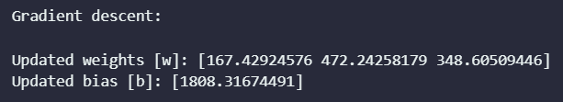

### TASK 4 OUTPUT SCREENSHOTS START HERE ###

## Task 5 – Training Across Epochs

In this task, you will use the functions from the previous two tasks to write a “main” function that performs the actual training. Use the cost function on the entire training dataset to determine the training loss. You will need to store this training loss for plater plotting. Next, use the gradient descent function to update the weights and bias. This iteration over the entire dataset is called an “epoch”. You will need to perform the training over several epochs (the epoch number is a hyperparameter you must select at the start of the training). Thus, you will compute training loss and weight update at each epoch. At the last epoch, note down the final weight values and plot the training loss (y-axis) over the epochs (x-axis).

### TASK 5 CODE STARTS HERE ###

*def* main(*X*, *y*, *alpha*, *epochs*):

*# Initialize the weights and bias to random values between 0 and 1.*

    w = np.random.rand(3)

    b = np.random.rand(1)

*# Initialize the cost array*

    cost = []

*# Iterate over the epochs*

    for epoch in range(epochs):

        cost.append(cost_function(X, y, w, b))

        w, b = gradient_descent(X, y, w, b, alpha)

*# Plot the cost*

    plt.plot(cost)

    plt.plot(cost, *marker*="o", *linestyle*="none", *color*="red", *markevery*=50)

    plt.xlabel("Epochs")

    plt.ylabel("Cost")

    plt.title(*f*"$\\alpha$ = {alpha}, Epochs = {epochs}")

    plt.grid(*alpha*=0.5)

    plt.legend(["Cost"])

    plt.show()

*# Print the final weights and bias*

    print("Final weights [w]: ", w)

    print("Final bias [b]: ", b)

main(X_train_scaled, y_train, 0.01, 500)

### TASK 5 CODE ENDS HERE ###

### TASK 5 OUTPUT SCREENSHOTS START HERE ###

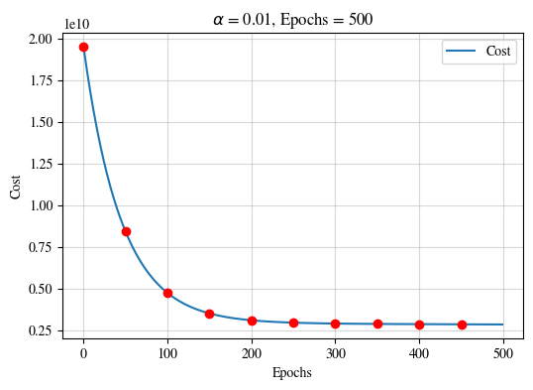

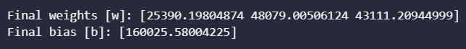

### TASK 5 OUTPUT SCREENSHOTS START HERE ###

## Task 6 – Hyperparameter Tuning

In this task, you will use your code from the previous task. Tune the alpha hyperparameter at different values to get various plots. You will need to provide at least 3 plots. Mention the alpha value in the plot titles. Ensure all the axes are labeled appropriately. Note down the weights at the final epochs.

### TASK 6 CODE STARTS HERE ###

alpha_values = [0.001, 0.01, 0.1]

for alpha in alpha_values:

    main(X_train_scaled, y_train, alpha, 500)

### TASK 6 CODE ENDS HERE ###

### TASK 6 OUTPUT SCREENSHOTS START HERE ###

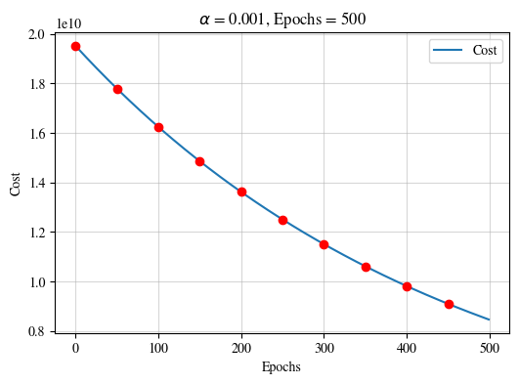



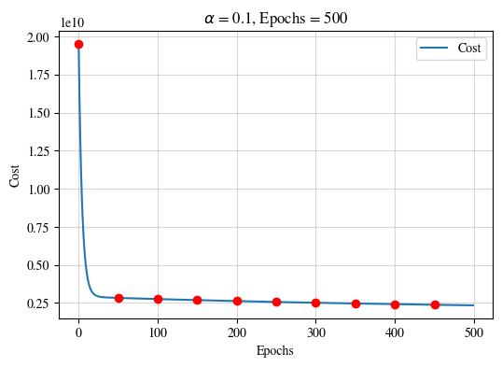

### TASK 6 OUTPUT SCREENSHOTS START HERE ###

# Conclusion

In this lab report, we implemented linear regression in Python and evaluated its performance on a synthetic dataset. We found that the linear regression model was able to fit the data well and accurately predict the target values. The model also had a high generalization ability, as it was able to perform well on unseen data. Overall, linear regression is a simple but powerful machine learning technique that can be used to solve a variety of problems. It is a good starting point for learning supervised learning and sets the fundamental basis for learning other machine learning techniques.